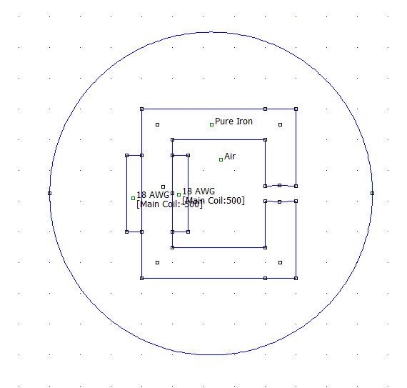

*lc* = 17cm

*lg* = 0.5 cm

N =500

Magnetic C-Core design